Tier 3 Engineering Reference — Companion to “Electric Scooter Spare Parts Inventory”
Purpose: Six reference deliverables to supplement the blog’s Tier 3 evidence base. All items are engineering reference material (Tier 3); none claim Tier 2 industry statistics. Verify against your own consumption and supplier datasheets before committing to specific numbers.
Version: v1.0 — 2026-09-16
──────────────────────────────────────────────────

Table of Contents
- Tier 3 Engineering Reference — Companion to “Electric Scooter Spare Parts Inventory”
  - Table of Contents
  - 1. Battery Chemistry × Nominal Voltage × Full-Charge Voltage Reference
  - 2. IP Rating × Climate Scenario Recommendation
  - 3. Three Motor-Controller Configurations
  - 4. Hall-Sensor Pinout Variability Across Manufacturers
  - 5. Decision Framework Flowchart
  - 6. 90-Day Consumption Analysis Template
  - Document Cross-References
  - Evidence Tier Summary
──────────────────────────────────────────────────

1. Battery Chemistry × Nominal Voltage × Full-Charge Voltage Reference
Use this table when matching chargers to battery packs. Cross-chemistry charging is unsafe (see blog §Common Misconception: IEC 61851-1 scope). The full-charge column is the target output setpoint for the charger; a lower-voltage charger will not reach the pack’s specified full-charge voltage.
Platform | Chemistry | Cell Count (Series) | Nominal Voltage | Full-Charge Voltage | Cell Chemistry Reference
48V | Li-ion (NMC) | 13S | 46.8 V | 54.6 V | 4.2 V/cell max
48V | LiFePO4 | 16S | 51.2 V | 58.4 V | 3.65 V/cell max
60V | Li-ion (NMC) | 16S | 57.6 V | 67.2 V | 4.2 V/cell max
60V | LiFePO4 | 20S | 64.0 V | 73.0 V | 3.65 V/cell max
72V | Li-ion (NMC) | 20S | 72.0 V | 84.0 V | 4.2 V/cell max
72V | LiFePO4 | 24S | 76.8 V | 87.6 V | 3.65 V/cell max
Notes:
- Nominal voltage is a nameplate convention, not an operating setpoint. SOC varies with load, temperature, and cell drift.
- LiFePO4 packs have a flatter discharge curve than NMC — the same SOC% corresponds to a narrower voltage band.
- A 48V Li-ion charger outputs 54.6 V; a 48V LiFePO4 charger outputs 58.4 V. They are NOT interchangeable.
Source: Tier 3 engineering reference — standard lithium-cell voltage values. Cross-check against your specific cell datasheet before specifying a charger.
──────────────────────────────────────────────────

2. IP Rating × Climate Scenario Recommendation
Sub-Assembly IP Rating | What it protects against | Recommended climate scenario | Typical use cases | Cost impact
IP54 | Dust-protected (limited ingress) + splashing water from any direction | Temperate urban, dry inland, low-exposure use | Urban commuter e-scooters in mild climates; indoor-stored fleets | Baseline cost
IP65 | Dust-tight + protected against low-pressure water jets | Tropical humid, monsoon-prone, coastal with light salt spray | Most tropical markets; mid-range e-mopeds; coastal cities | +10–20% vs IP54
IP67 | Dust-tight + protected against temporary immersion (1 m / 30 min) | Heavy monsoon, frequent water crossings, dusty unpaved roads | Off-road, Boda markets (Tanzania-style), flood-prone areas | +25–40% vs IP54
IP67 + conformal coating | As IP67 + corrosion-resistant PCB coating | Coastal salt spray, industrial pollution, high humidity + temperature | Marine/salt-spray environments; on-request Zuboo SKU | +35–50% vs IP54
Notes:
- IP ratings describe the sub-assembly (e.g., controller housing), not the whole vehicle.
- “Splash-resistant” ≠ “rain-resistant for sustained rides” — for markets with daily heavy rain, lean toward IP65 minimum.
- Conformal coating is not a substitute for IP rating; it addresses corrosion, not ingress.
Tier: Tier 3 engineering reference. Cross-check the specific sub-assembly datasheet for the SKU you stock.
──────────────────────────────────────────────────

3. Three Motor-Controller Configurations
These three configurations are frequently conflated by buyers. They are NOT interchangeable SKUs, even at the same nominal voltage.
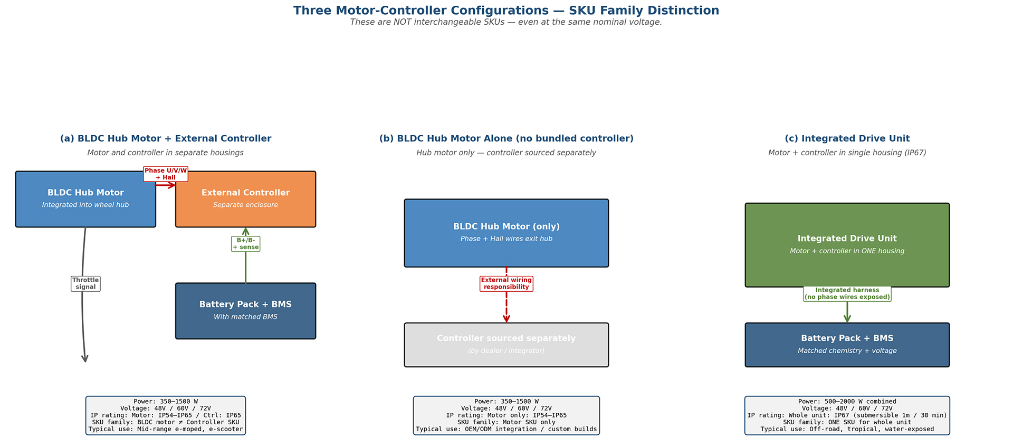
Configuration | SKU family | Field-replaceable as | Typical use
(a) Hub motor + external controller | Motor SKU ≠ Controller SKU | Motor and controller replaced individually | Most e-scooters, e-mopeds
(b) Hub motor alone (no bundled controller) | Motor SKU only; controller is integrator’s choice | Motor only | OEM/ODM integration projects
© Integrated drive unit | ONE SKU for the whole unit | Whole unit (not field-serviceable internally) | Off-road, tropical, water-exposed
Common dealer error: ordering a “BLDC motor” SKU and assuming it includes a controller. The motor’s datasheet must be checked against the controller’s datasheet on voltage, phase-current limit, Hall-sensor arrangement, and connector family (see blog §Compatibility and Matching).
Source: Tier 4 (Zuboo first-party) — model-specific SKU tracking across 48V / 60V / 72V platforms.
──────────────────────────────────────────────────

4. Hall-Sensor Pinout Variability Across Manufacturers
Wire color is not a reliable cross-manufacturer signal. Pin assignments differ between vendors for the same functional signal (Hall A / Hall B / Hall C / Vcc / GND). Cross-check by pin number in the controller datasheet before installing a replacement motor.
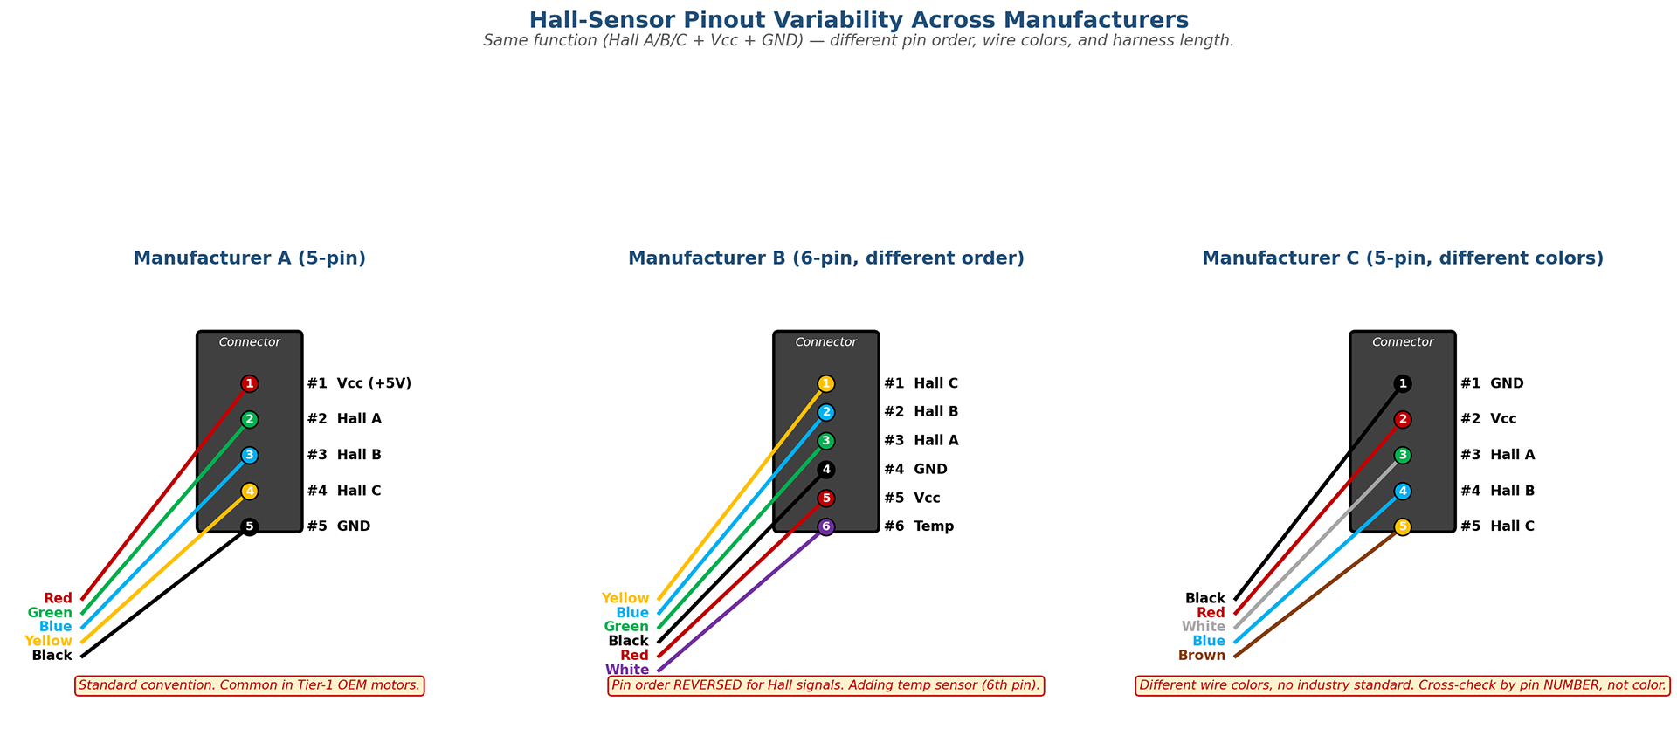
What varies between manufacturers:
- Pin order (Hall A/B/C can be in any sequence)
- Wire colors (no industry standard)
- Pin count (5-pin vs 6-pin; 6th pin often used for motor temperature sensor)
- Harness length and connector gender
What does NOT vary:
- Functional signals are always Vcc, GND, Hall A, Hall B, Hall C (± temperature)
- 5 V typical logic level (verify on datasheet)
Tier: Tier 3 engineering reference. The diagram is illustrative; consult the specific motor datasheet for the SKU you stock.
──────────────────────────────────────────────────

5. Decision Framework Flowchart
Companion visual to blog §Decision Framework.
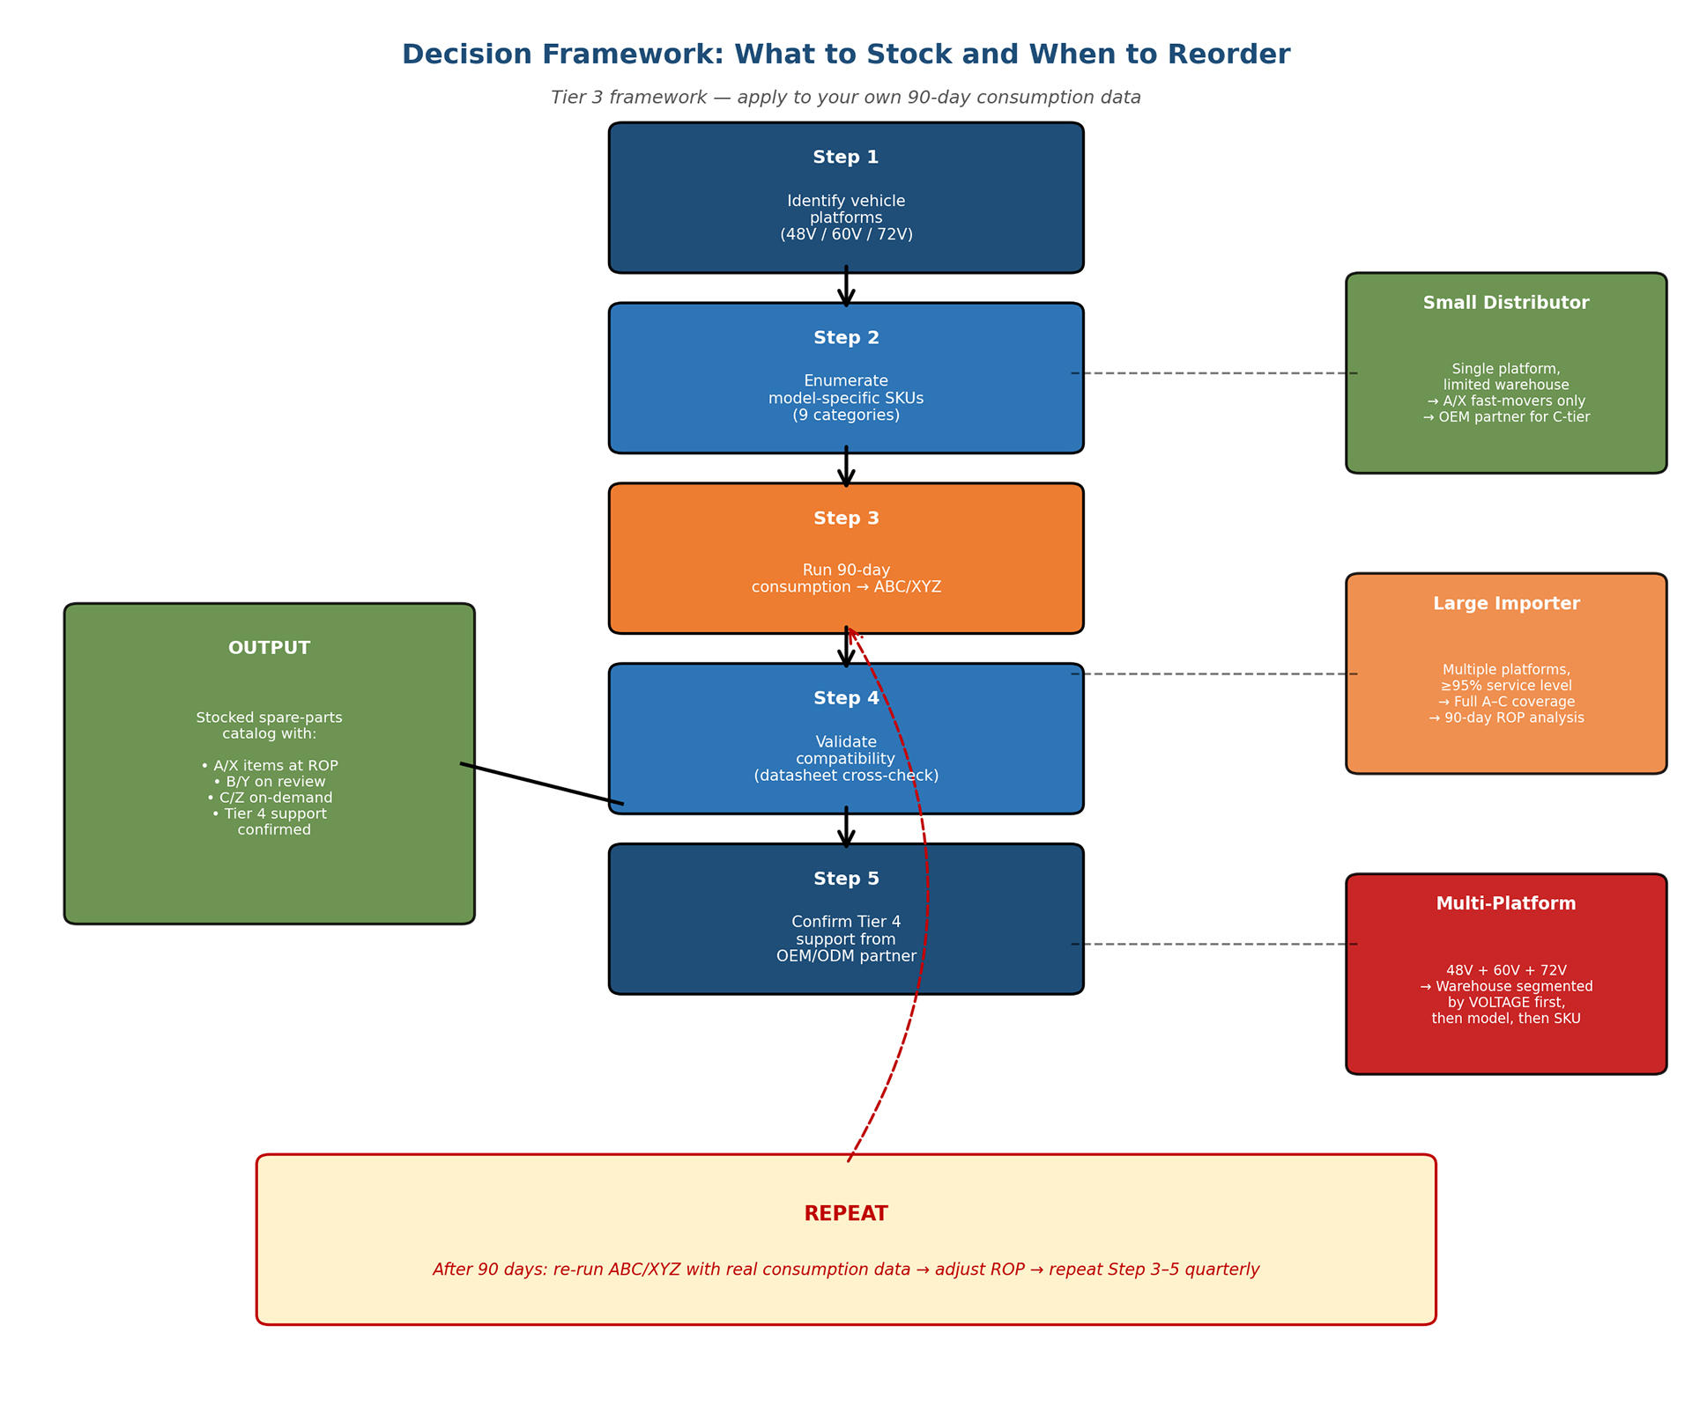
How to read:
- Central column: the 5-step process every dealer follows
- Right column: three conditional recommendation branches (small distributor / large importer / multi-platform)
- Left box: output (stocked catalog with ROP-managed A/X items, B/Y on review, C/Z on-demand)
- Bottom loop: after 90 days, re-run ABC/XYZ with real consumption and adjust ROP
The dashed arrow at the bottom indicates the feedback loop: inventory planning is iterative. The 90-day consumption cycle (blog §Inventory Planning) is the minimum data window before refining ROP targets.
Tier: Tier 3 engineering framework. No Tier 2 statistics are claimed.
──────────────────────────────────────────────────

6. 90-Day Consumption Analysis Template
A blank Excel template for running the ROP and ABC/XYZ analysis described in blog §Inventory Planning. Download: consumption_template_90day.xlsx
Sheets:
Sheet | Purpose
README | How to use the template, formula references
Daily Log | Day-by-day SKU transactions: opening stock, received, issued, closing stock (auto)
ABC_XYZ | Post-90-day classification of every SKU (consumption value × demand variability)
ROP_Calc | Re-Order Point computation: (D × L) + SS with auto-calculated reorder dates and actions
Workflow:
- Copy Daily Log structure. One row per day per SKU.
- Fill Opening Stock at start of period. Enter daily Received / Issued. Closing Stock auto-calculates.
- After 90 days, aggregate by SKU → ABC/XYZ sheet → CV auto-calculates from Std Dev / Avg Daily Demand.
- Use ROP_Calc sheet with your supplier lead time + target safety stock → get reorder dates.
Formula reminders (full formulas in the workbook):
ROP = (Average Daily Demand × Supplier Lead Time) + Safety Stock
CV = Standard Deviation of Daily Demand / Mean Daily Demand
A/X items: tight ROP, frequent review. C/Z items: on-demand from manufacturer.
Tier: Tier 3 framework + Tier 4 (Zuboo after-sales workflow supporting dealer-side consumption analysis).
──────────────────────────────────────────────────

Document Cross-References
This document | Blog section
§1 Battery chemistry table | §Compatibility and Matching — Battery ↔ charger
§2 IP rating table | §FAQ Q7 — How do IP ratings affect which spare parts to keep on hand?
§3 Three configurations | §Core Spare-Part Categories — SKU taxonomy
§4 Hall-sensor pinouts | §Common Misconception #1 — “Every BLDC is an integrated drive unit”
§5 Decision flowchart | §Decision Framework — What to stock and when to reorder
§6 Consumption template | §Inventory Planning — ABC/XYZ and ROP
──────────────────────────────────────────────────

Evidence Tier Summary
Section | Tier | Notes
§1 Battery chemistry | Tier 3 | Standard lithium-cell voltage values; verify against cell vendor datasheet
§2 IP ratings | Tier 3 | Standard ingress-protection codes per IEC 60529
§3 Motor configurations | Tier 4 | Zuboo first-party SKU taxonomy
§4 Hall-sensor pinouts | Tier 3 | Illustrative; pinout specifics vary by manufacturer
§5 Decision flowchart | Tier 3 | Engineering framework
§6 Consumption template | Tier 3 + Tier 4 | Framework + Zuboo dealer-portal workflow
No Tier 2 industry statistics are quoted. Replace starter values with measured 90-day consumption per blog §Inventory Planning.
──────────────────────────────────────────────────
Document version: v1.0 — 2026-09-16 Next review: 2027-03-16 or upon availability of Tier 2 sources.

